  PATIENT REGISTRATION | Date
2044 Bedford Road Bedford, Texas 76021 (817) 835-0885, info@mhaom.com

Meridian Harmonics Acupuncture & Oriental Medicine

D. Mark Tryling, LAC, Dipl. AC,CH

PERSONAL HISTORY

NAME:__________________________________ |  | EMPLOYER:_____________________________
STREET:________________________________ |  | BUSINESS PHONE:_______________________
CITY:___________________________________ |  | MOBILE PHONE:_________________________
ST:_________________ZIP:_________________ |  | PAGER:_________________________________
BIRTHDATE:_________AGE:______SEX M F |  | E-MAIL:_________________________________
BIRTH PLACE: __________________________ |  | WEBSITE:_______________________________
BIRTH TIME: _________________ AM | PM | NAME OF SPOUSE:_______________________
HOME PHONE:___________________________ |  | EMERGENCY CONTACT & PH #:
DRIVERS LIC #:__________________________ |  | ________________________________________
TYPE OF WORK:_________________________ |  | RELATIONHIP:___________________________
CHECK ONE: ! MARRIED ! SINGLE | ! WIDOWED ! DIVORCED ! SEPARATED
# OF CHILDREN_____________
WHO IS RESPONSIBLE FOR YOUR BILL: ! SELF |  | ! SPOUSE ! OTHER

HOW WERE YOU REFFERRED TO OFFICE?:____________________________________________

CURRENT HEALTH CONDITION

PURPOSE OF THIS APPOINTMENT:_______________________________________________________

OTHER DOCTORS SEEN FOR THIS CONDITION: ! YES | ! NO WHO?_____________________
TYPE OF TREATMENT__________________________________________________________________
RESULTS________________________________________
WHEN DID THE CONDITION BEGIN?____________________ NEW CONDITION |  | ! YES ! NO
IS CONDITION ! JOB RELATED ! AUTO RELATED | ! HOME INJURY | ! FALL
OTHER:__________________

DATE OF ACCIDENT:_________________ TIME OF ACCIDENT:_______________________________

OTHER CONDITIONS WHICH YOU SUFFER FROM:_________________________________________

WEIGHT _________ HEIGHT _________ BLOOD PRESSURE _________ PULSE RATE ________

PAST HEALTH HISTORY

MAJOR SURGERIES: ! APPENDECTOMY ! TONSILLECTOMY ! GALLBLADDER !

HERNIA ! BACK SURGERY ! BROKEN BONES ! OTHER________________________________________________________________________________

MAJOR ACCIDENTS OR FALLS___________________________________________________________

_______________________________________________________________________________________

PREVIOUS ACUPUNCTURE CARE ! NONE ! DOCTOR’S NAME & APPROXIMATE DATE OF LAST VISIT___________________________________________________________________________
List medications you are currently taking

Meds Strength How many per day? For how long?


Vitamins taken in the past two months:

List substances or medications you are allergic to:

_____________________________________________________________________________________________

List significant family history:

_____________________________________________________________________________________________
_____________________________________________________________________________________________
_____________________________________________________________________________________________

Below is a list of conditions, which may seem unrelated to the purpose of your appointment. However, there are many conditions that respond favorably to treatment, which will increase your body’s ability to function correctly. This office specializes in such treatment and if you wish, an individualized program will be suggested.

Check any of the following conditions you currently have or have had in the past. Also, check if any of the following are a significant part of your medical history.

! AIDS/HIV | ! Emphysema | ! Mumps | ! Tuberculosis
! Alcoholism | ! Epilepsy | ! Pacemaker | ! Typhoid Fever
! Allergies | ! Goiter | ! Pleurisy | ! Ulcers
! Appendicitis | ! Gout | ! Pneumonia | ! Venereal Disease
! Arteriosclerosis | ! Heart Disease | ! Polio | ! Whooping Cough
! Asthma | ! Hepatitis | ! Rheumatic Fever | ! Other (specify)
! Birth Trauma | ! Herpes | ! Scarlet Fever | __________________
! Cancer | ! High Blood Pressure | ! Seizures | __________________
! Chicken Pox | ! Measles | ! Stroke | __________________
! Diabetes | ! Multiple Sclerosis | ! Thyroid Disorders | __________________
Your Diet
Appetite ! Hi ! Lo | ! Artificial Sweetener | Thirst for Water:
! Coffee | ! Sugar | # of Glasses per Day
! Soft Drinks | ! Salty Food | __________________
Your Lifestyle
! Alcohol | ! Stress | Type: | Type:
! Tobacco | ! Occupational | _______________ | _______________
! Marijuana | Hazards | Frequency:_________ | Frequency:_________
! Drugs | ! Regular Exercise

General Symptoms
! Strongly like Cold | ! Poor Sleep | ! Poor Circulation | ! Bleed or Bruise
Drinks | ! Heavy Sleep | ! Shortness of Breath | Easily
! Strongly like Hot | ! Dream Disturbed | ! Fever | ! Peculiar Taste:
Drinks | Sleep | ! Chills | Metallic or Spicy
! Heavy Appetite | ! Fatigue | ! Night Sweats | ! Food Cravings:
! Skip Meal:________ | ! Lack of Strength | ! Sweats Easily | Sweets, Salty, Spicy,
! Recent Weight Loss | ! Bodily Heaviness | ! Muscle Cramps | Other
! Recent Weight Gain | ! Cold Hands or Feet | ! Vertigo or Dizziness | ___________________
Head, Eyes, Ears, Nose and Throat
! Glasses | ! Cataracts | ! Sinus Problems | ! Nose Bleeds
! Eye Strain | ! Teeth Problems | ! Excessive Phlegm | ! Ringing in Ears
! Eye Pain | ! Grind Teeth | ! Color of Phlegm | ! Poor Hearing
! Red Eyes | ! TMJ | ___________________ | ! Earaches
! Itchy Eyes | ! Facial Pain | _ | ! Headaches
! Spots in Eyes | ! Gum Problems | ! Recurrent Sore | ! Migraines
! Poor Vision | ! Sores on Lips or | Throat | ! Concussions
! Blurred Vision | Tongue | ! Swollen Glands | ! Other Head/Neck
! Night Blindness | ! Dry Mouth | ! Lumps in Throat | Problems
! Glaucoma | ! Excessive Saliva | ! Enlarged Thyroid | __________________
Respiratory
! Pneumonia | ! Asthma/Wheezing | Thick or Thin? | ! Coughing Blood
! Difficulty breathing | ! Cough | __________________ | ! Coughing AM or PM
when lying down | Wet or Dry? | Color of Phlegm:
! Chest pain | ______________ | __________________
Cardiovascular
! High Blood Pressure | ! Fainting | ! Tachycardia | ! Irregular Heartbeat
! Low Blood Pressure | ! Chest Pain | ! Heart Palpitations
! Blood Clots | ! Difficulty Breathing | ! Phlebitis
Gastrointestinal
! Abdominal Fullness | ! Bad Breath | ! Intestinal Pain or | Bowel Movements
! Nausea | ! Diarrhea | Cramping | Frequency:_________
! Vomiting | ! Constipation | ! Itchy Anus | Color:_____________
! Acid Reflux | ! Laxative Use | ! Burning Anus | Odor:______________
! Gas | ! Black Stools | ! Rectal Pain | Texture:____________
! Hiccups/Burping | ! Mucous in Stools | ! Hemorrhoids
! Bloating |  | ! Anal Fissures

Musculoskeletal

! Muscle Spasms | ! Neck/Shoulder Pain | ! Joint Pain | ! Limited Use
! Restless Legs | ! Muscle Pain | ! Rib Pain | ! Other (describe):
! Tender spots | ! Upper Back Pain | ! Limited Range of | __________________
! Clicking Joints | ! Lower Back Pain | Motion

Skin and Hair

! Rashes | ! Acne | ! Hair: Oily or Dry | ! Other Hair/Skin
! Hives | ! Dandruff | ! Skin: Oily or Dry | Problem:
! Ulceration | ! Itching | ! Fungal Infection | __________________
! Eczema | ! Hair Loss | ! Boils | __________________
! Psoriasis | ! Hair Thinning | ! Sensitive Skin | __________________
Neuropsychological
! Stress | ! Poor Memory | ! Easily Stressed | ! Seeing a Therapist
! Seizures | ! Depression | ! Abuse Survivor | ! Other (specify):
! Numbness | ! Anxiety | ! Considered Suicide | __________________
! Tics | ! Irritability | ! Attempted Suicide
Genitourinary
! Pain on Urination | ! Incomplete Urination | ! Decreased Libido | ! Nocturnal Emission
! Frequent Urination | ! Venereal Disease | ! Kidney Stones | ! Interstitial Cystitis
! Urgent Urination | ! Bedwetting | ! Impotence | ! Other:____________
! Blood in Urine | ! Wake to Urinate | ! Premature
! Incontinent | ! Increased Libido | Ejaculation
Gynecological
Age Menses Began: | ! Irregular Periods | Date of Last | # of
______ | ! Painful Periods | PAP:_______________ | Pregnancies:______
Cycle | ! Vaginal Odor | ! Clots | # of Live
Length:___________ | ! Vaginal Sores | ! PMS | Births:___________
Flow | ! Itching ___________ | ! Breast Lumps | # of Premature
Duration:__________ | ! Vaginal Discharge | ! Breast Tenderness | Births:_____________
Date Last Period | Color:_____________ | ! Breast Swelling | Age of
Began:_____________ |  | ! Back Pain | Menopause:______

PLEASE MARK AREAS WHERE YOU FEEL DISCOMFORT OR PAIN. MARK ALL THAT APPLY
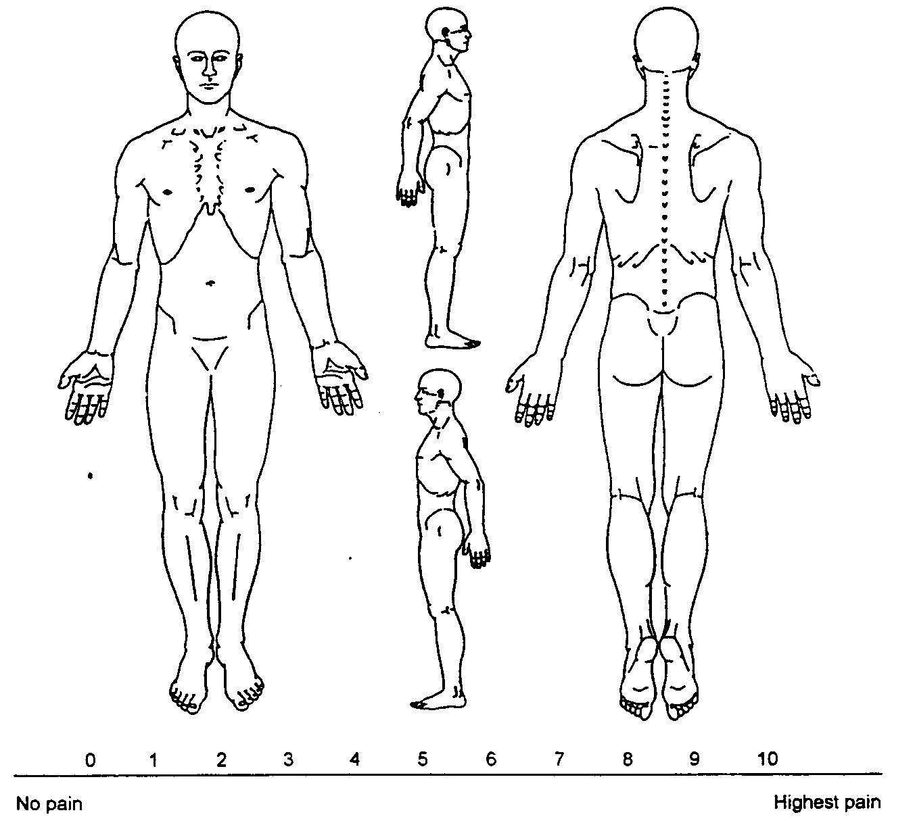

AVERAGE DAILY PAIN LEVEL 0 = NO PAIN, 10 = EXTREME PAIN

PATIENT/ GUARDIAN SIGNATURE __________________________________________________DATE: ____________________
GENERAL CLINIC INFORMATION & PATIENT/PRACTITIONER AGREEMENT

MERIDIAN HARMONICS ACUPUNCTURE & ORIENTAL MEDICINE 2044 Bedford Road Bedford, Texas 76021 (817) 835-0885, info@mhaom.com
PAYMENT POLICIES

- If you are an existing patient and any of your personal information has changed, i.e. address, telephone, email address, etc., please advise us so that we may update our records.

- Our clinic hours are Tue/Wed/Thu/Fri 8:30am – 11:30am, 2:00pm - 7:00pm. We are closed Saturday, Sunday & Monday.
- INSURANCE PATIENTS – We do not file insurance claims. Refer to the Insurance Information form

- MISSING OR CHANGING APPOINTMENTS: We have set up a specific course of treatment for you. A specific number of treatments in a set amount of time are required for us to get the results we both desire. Thus, if you need to change the time of your appointment, come another time the same day. If the same day is not possible, be sure to make up the missed appointment within one week. There is 24-hour cancellation policy. WE HAVE A 3 STRIKE POLICY. IF YOU MISS AN APPOINTMENT AND DO NOT

CALL YOU WILL BE RESPONSIBLE FOR A $50 SERVICE CHARGE ON YOUR 3RD MISSED
APPOINTMENT.

- I understand and agree that all services rendered me are charged directly to me and that I am personally responsible for payment. I also understand that if I suspend or terminate my care and treatment, any monies paid for treatment are non-refundable.
- Full payment is due at the time of service. We accept MasterCard, Visa, Discover, cash and personal checks.

- We will provide you with a receipt – PLEASE RETAIN THIS RECEIPT for your records. This is your only copy of proof of payment, for yourself or third parties (attorney, insurance company, employer, etc.).
Always make copies of your receipt if you have to provide a copy to a third party. Never discard or give your original receipt away.

- There is a $30 charge for returned checks. There is a $25 charge for our office to make copies of any portion of your records. We will email receipts for all service charges.

o Credit Card Information

o Name on Card: ______________________________________________________________

o Card Type: MC V Disc; Card Number: ___________________________________________

o Card Expiration Date: _________________________________________________________

o Card Security Code: __________________________________________________________

o Card Billing Address Zip Code: __________________________________________________

I have read, understand and agree to the above clinical policies:

Patient Signature _________________________________ Date _____________________________
CLINIC & TREATMENT PROCEDURES

MERIDIAN HARMONICS ACUPUNCTURE & ORIENTAL MEDICINE

2044 Bedford Road Bedford, Texas 76021 (817) 835-0885, info@mhaom.com
- Oriental medicine is one of the oldest, most complete systems of medicine in the world. Anything you would normally seek treatment for from a western doctor are conditions that are suitably treated by Traditional Chinese Medicine. Our goal is to help educate our patients about TCM. We strive to treat existing conditions as well as promoting preventative measures. Our goal for each patient is to help with their healthcare needs so to achieve harmony & health throughout the whole body.

- Acupuncture treatments are performed on a padded treatment table with the patient in the prone or supine position. If you are not able to lie down in either position, we can treat most, but not all, conditions in a zero gravity chair. Please inform us prior to your appointment if you are unable to be treated on a treatment table so that we can make necessary accommodations.

- Please eat a healthy meal prior to your appointment. Don’t come hungry to your appointment.

- We attempt to send appointment reminders via text messaging the day before your appointment; you may confirm your appointment by responding to the text. If you do not receive text messages then let us know how you would like to be notified of your upcoming appointment.

- Most acupuncture treatments require access to regions on the arms and legs or possibly the back. Please wear appropriate loose clothing or bring a change of clothes. Patient gowns are available for treating conditions on the back, chest or abdomen.

- We reserve 60 minutes for your appointment, of which 35-40 minutes is the actual treatment time. The remaining 20-25 minutes is for checking in, your diagnostic intake with the acupuncturist, and checking out. If you are late for your appointment, your treatment time will be the remaining portion of your allotted appointment time. If you are unable to keep your appointment time, we require you to give us 24 hours notice. If you are early for your appointment you may not be able to be treated before your actual appointment time. Our goal is punctuality; we try to streamline appointments so that there is no waiting time for our patients.

- We attempt to treat as many conditions possible during your appointment. However, we do not use an excessive number of acupuncture pins. In fact, treatments using fewer pins are more effective than those with more.
- Many conditions may require both acupuncture and Chinese herbal medicine for proper treatment. If you are a candidate for herbal medicine from our Chinese herbal compounding pharmacy, your herbal formula is customized specifically for you and should not be shared. Please notify us of all medicines (Rx & OTC & supplements) you are currently taking. You will be given detailed instructions on how to use your herbs with existing medications and supplements. A typical herbal course of treatment is 1-3 months. Re-evaluation will be done at that time.

- We expect patients to be courteous to our staff and to other patients in the office receiving treatments. So as not to disturb our other patients, this includes that cellphones be silenced or turned off & not using strong perfumes or smoking prior to your appointment. Conversations must be kept at a low volume. Please do not bring small children to our office with the intention of leaving them unattended. We do not have a play area for them or a designated person to supervise them.

- Meridian Harmonics is NOT an emergency medical clinic. If you are having a medical emergency, please CALL 911 or have someone take you to the nearest emergency medical clinic or hospital ER. Please do not call or show up at our office if you are experiencing a medical emergency.

- We are not available after hours. If you call our office after hours, please leave a message and we will return your call during business hours. Messages are not checked after hours or during the weekends. If we are helping patients, phone calls will roll over to the messaging service during the business day. Messages are typically returned in the afternoon. You may also contact us via email: info@mhaom.com .

- During business hours we will attempt to contact you by phone, email or text messaging. You may do the same with us.

I have read, understand and agree to follow the above clinical procedures:

Patient Signature _________________________________ Date _____________________________

INSURANCE GUIDELINES

MERIDIAN HARMONICS ACUPUNCTURE & ORIENTAL MEDICINE 2044 Bedford Road Bedford, Texas 76021 (817) 835-0885, info@mhaom.com
We want every patient to have the opportunity to receive treatment in this office. It is important to us that you receive the highest standard of care.

We apologize that the following insurance information is so complicated. It is not our fault. There are many plans and each has different specific details of how they pay (or do not pay) for acupuncture. To become an in-network provider, health insurance companies require the medical provider to file the insurance claim on behalf of the patient. This would require additional costs that would have to be passed to the patient. In order to keep our fees a low as possible, Meridian Harmonics has chosen not to incur additional costs. Consequently, the acupuncturist is an out-of-network provider in many of the large health insurance plans.

While many health plans now offer some coverage for acupuncture, there are specific details that must be verified for each individual patient. You must contact your insurance company prior to your first visit. When you do so, ask if your plan covers acupuncture, preformed by a licensed acupuncturist. If they say there is no coverage that means you will be responsible for full payment. Even if you find Mark Tryling’s name in a booklet of your insurance company’s list of accepted providers, it does not always mean you are covered for our services.

Some insurance plans will pay for acupuncture but only for a limited number of treatments or only for certain specific medical conditions. Some will only pay when a medical doctor performs acupuncture (even though medical doctors receive no training in acupuncture). In other words, just because your insurance company says they cover acupuncture, it does not mean they will reimburse for our services in treating you. Even when you verify the coverage information, there are some instances when an insurance company ends up not reimbursing for those treatment or diagnosis codes.

Some insurance plans say they cover acupuncture when all they offer is a discount off the Acupuncturist’s fees. Most discount plans (also called Access plans) require the Acupuncturist to discount 20-25% off their usual insurance fees. This is a direct payment service – payment is made at the time of service at the discount rate. Discount plans also allow the Acupuncturist to charge for an initial consultation and for acupressure/massage if performed. DON’T CONFUSE A DISCOUNT PLAN WITH HAVING INSURANCE
FOR ACUPUNCTURE.

This office does not file insurance claims on your behalf. We require payment, in full, for all services on the day of your treatment. Thank you for your cooperation in this matter. Never send your original receipt to your insurance company. Make a copy of your receipt to send them and verify that it is completely legible. Illegible receipts can delay your reimbursement on average of two to six weeks.

PLEASE VERIFY PRIOR TO YOUR FIRST APPOINTMENT

In order for YOU to file a claim with your insurance company, you must provide your insurance company with the following CPT (treatment codes), listed below, and an ICD (diagnosis code that we will provide at time of treatment on your receipt). Verify that your insurance company will reimburse you on the office visit and/or the treatment codes shown below:

NEW PATIENT OFFICE VISIT: | 99203, 99204, 99205
ESTABLISHED PATIENT OFFICE VISIT: | 99213, 99214, | 99215
TREATMENT CODES: | 97810, 97811, | 97813, 97814

Insurance companies require a minimum of 1) the CPT code, listed above, 2) a description of your symptoms and a 3) corresponding diagnosis code or ICD code. Some insurance companies and certain plans will reimburse for only certain diagnosis codes. It is our experience that some insurance companies will not reimburse for anything but ICD codes corresponding to pain. If this is the case, then your treatment and your receipt will indicate a diagnosis relating to a particular type of pain. Please verify what diagnosis codes your particular plan covers.

Finally, please verify with your insurance company how many acupuncture treatments are covered per ICD diagnosis code. Our experience is that some insurance companies will only reimburse for as little as ten acupuncture treatments. If your treatment plan requires more treatments than are allowed by your particular plan, then your subsequent treatments will require a different ICD diagnosis code.

This office does not provide itemized statements for you, your insurance companies, or attorneys. Your receipt is your only proof of treatment and payment. For all legal matters, contact your primary care or referring physician for your patient records. In the case of personal injury or workers compensation cases, we do not provide patient records or billing information to attorneys or insurance companies. THIS OFFICE WILL NOT ENTER INTO DISPUTES WITH YOUR

INSURANCE CARRIER OVER ANY CLAIM
PRIVACY PRACTICES ACKNOWLEDGEMENT

CONSENT TO TREAT ACKNOWLEDGEMENT

ACKNOWLEDGEMENT FORM

I have read the Notice of Privacy Practices and I have been provided an opportunity to review it. I have read the Consent to Treat & Arbitration Agreement and agree to its terms.

Retroactive Effect: If patient intends the arbitration agreement to cover services rendered before the date it is signed (for example, emergency treatment) patient should initial here_______________. Effective on the date first professional services are provided.

I hereby authorize the Practitioner/Therapist to treat my conditions, as he/she deems appropriate through the use of Acupuncture, Oriental Medicine, Chinese medical massage, Nutrition, or other natural healing methods, which he/she is licensed to perform in the state of Texas. The patient also agrees that he/she is responsible for all bills incurred at this office. The Practitioner will not be held responsible for any pre-existing medically diagnosed conditions, nor for any medical diagnosis. Patients diagnosed with cancer who have already sought oncology treatment may receive adjunctive pain therapy and nutritional supplementation to promote and support immune function and detoxification.

NOTICE: BY SIGNING THIS CONTRACT YOU ARE AGREEING TO HAVE ANY ISSUE OF MEDICAL

MALPRACTICE DECIDED BY NEUTRAL ARBITRATION AND YOU ARE GIVING UP YOUR RIGHT TO

A JURY OR COURT TRIAL.

Patient – Provider Agreement

I have been informed that the medical services or supplies I am requesting may be non-covered services of my health plan. Therefore, my health plan may not pay for these services and I have elected to have these services or supplies provided at my own expense. In the case of any legal matters as a result of a personal injury or workers compensation case, I agree not to have Meridian Harmonics responsible to provide copies of any treatment records or billing statements to any entity. I have read and agree to the above policies.

Name _________________________________________________________________________

Patient Signature __________________________________________ Date _________________
MERIDIAN HARMONICS ACUPUNCTURE & ORIENTAL MEDICINE

- MARK TRYLING, LAC, LIC #AC00563 2044 Bedford Road Bedford, TX 76021
PHONE:(817) 835-0885

Condition treated: ________________________________________________________

NOTICE TO PATIENT

(Pursuant to the requirements of section 183.6(e) of this title, relating to Denial of License; Discipline of Licensee, and TEX. OCC. CODE ANN., ‘205.351, governing the practice of acupuncture.)

I (patient’s name) __________________________________________, am notifying D. Mark Tryling, LAC, Dipl AC, CH of the following:

_____ Yes _____ No I have been evaluated by a physician or dentist for the condition being treated within 12 months before the acupuncture was performed. I recognize a physician or dentist should evaluate the condition I am being treated for.

_____ Yes _____ No I have received a referral from my chiropractor within the last 30 days for

acupuncture.

After being referred by a chiropractor, if after 120 days or 30 treatments, whichever comes first, no substantial improvement occurs in the condition being treated, I understand that the acupuncturist is required to refer me to a physician.

Optional Form to be completed by Patient, Attesting that the Acupuncturist Has Referred Him/Her

(Pursuant to the requirement of section 183.6(e) of this title and TEX. OCC. CODE ANN., ‘205.351, governing the practice of acupuncture.)

The acupuncturist has referred me to see a physician. It is my responsibility and choice whether to follow his or her advice.

Patient’s signature _______________________________________________ Date ____________________

Acupuncturist’s signature _________________________________________ Date ____________________

